Community Partnerships for Disaster Planning:
The EnRiCH Project Experience
Tracey O’Sullivan, PhD
EUNAD international workshop Prague 30-31.10.2013

Lead Investigator:
Tracey O’Sullivan, UOttawa
Federal Partners:
Public Health Agency of Canada, Division of Aging & Seniors (Patti Gorr)
Human Resource & Skills Development Canada, Office of Disability Issues (Erik Lapalme)
Industry Partners:
Canadian Red Cross (Mona O’Brien, Karen Charles, Louise Geoffrion)
Nova Scotia Department
of Emergency & Social Services (John Webb, Joanne Lawlor)
Ville de Gatineau (Jacques Rathwell, Gilles Desjardins, Nathalie Bourget- CSSS)
Region of Waterloo (Steve LaRochelle)
211 Québec City (Claude Vanasse, Nicole Pare)
Academic Partners:
University of Ottawa
(Wayne Corneil, Louise Lemyre Craig Kuziemsky, Sanni Yaya, Linda Garcia, Dan Lane,
Jeff Jutai)
Carleton University
(Behnam Behnia)
Funded by the Canadian Centre for Security Science (CSS)


The EnRiCH Collaboration
- Community-based participatory research focused on inclusive engagement and fostering collaboration to enhance resilience among high risk populations
- Bringing together expertise from front line response organizations, community associations, governance and policy, academia, research and knowledge translation, health economics, community health promotion, disaster management and national security.
- Asset or functional capability-oriented approach
www.enrichproject.ca

Images of Resilience
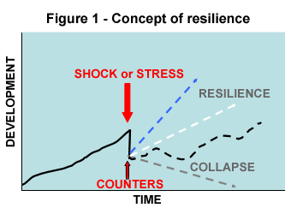
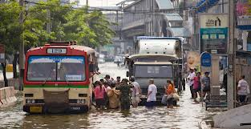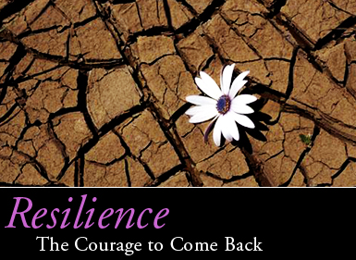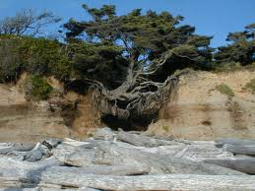
Community: Ottawa
- House A: retired couple, both mid-70’s; the woman had a hip replacement 4 months ago
- House B: working couple, 4 boys (4 yrs old, 14, 16, 18)
- House C: retired couple, both mid-70’s; husband had heart attack in 2012, wife has history of depression

Aspects of Community Resilience
- Resistance, Absorption, Restoration (Kahan et al., 2009)
  - End states or outcomes
  - Build back better
- Key concepts (Chandra, 2011)
  - Engagement
  - Partnerships
  - Sustained local leadership
  - Education about risks
  - Access to services (eg. Health services)
  - Integration of preparedness and wellness
  - Repaid restoration of services / networks
  - Individual preparedness & self-sufficiency
  - Targeted strategies to empower and engage high risk populations
  - Financial resiliency – families and businesses
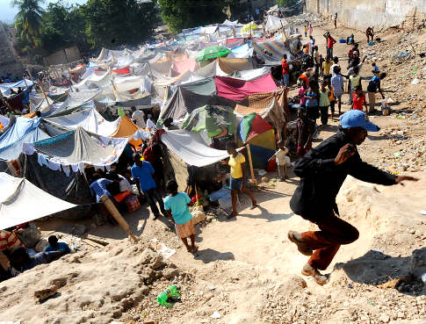
Lessons from EnRiCH
- Awareness and relationships are key factors to engage communities to become more resilient
- True engagement is reaching out – and then really empowering people to participate
- Asset-based approach requires changing the lens through which we see different groups in the population
- Disasters are characterized by disproportionate impacts on marginalized and otherwise high-risk groups.
- Vulnerability to disasters is increasing due to
  - Population growth / density
  - Inadequate hazard knowledge
  - Rising rates of poverty and homelessness
  - An aging population and infrastructure
  - Increased social inequities (Enarson & Walsh, 2007)
  - Because emergencies cause a disruption in social and physical environments, it is important to consider those with functional limitations that could be at greater risk
Resilient communities
- Have strong social networks and accessible public organizations (McKnight, 2010)
- Effective communication strategies between leading members of community organizations (Norris et al., 2008)
- Recognize the assets of individuals, organizations and communities (O’Sullivan et al., 2013)
 Eatst.foodnetwork.ca
EnRiCH Intervention Framework
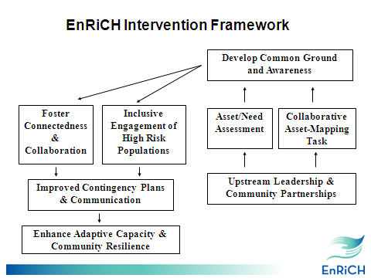

EnRiCH Community Intervention
The EnRiCH Community Intervention was designed as a template for communities to tailor to their own context and priorities
- Asset/Need Assessment (focus group using SIM format)
- EHRIT Orientation and Networking Session
- Online Collaborative Planning Task (8-10 weeks)
- Table Top Exercise
The EnRiCH Manual is available at http://enrichproject.ca/publications-and-resources.html
Asset/Need Assessment in Target Communities
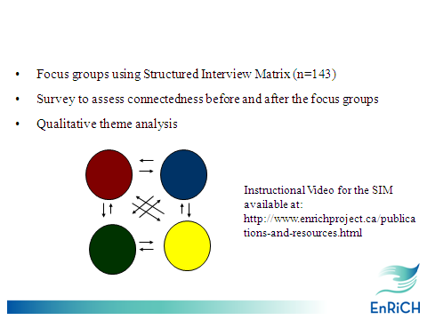

“I very much like this format versus other traditional [focus group] methods. This format allowed for each person’s response and for an interactive flow. [It] moved along efficiently and maintained the momentum of conversation”
“The process was very useful and seemed to truly collect useable useful information”
“I enjoyed it... it kept everyone engaged and ensured that everyone got to participate”
“Very good discussion. I think the most important thing from this is the fact that multiple organizations came together and started a conversation”

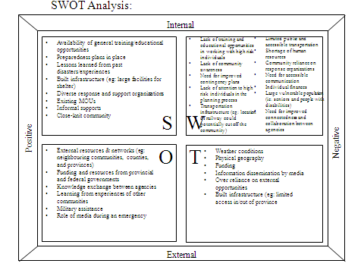

S:
- Availability of general training/educational opportunities
- Preparedness plans in placeLessons learned from past disasters/experiences
- Built infrastructure (eg: large facilities for shelter)
- Diverse response and support organizations
- Existing MOUs
- Informal supports
- Close-knit community
W:
- Lack of training and educational opportunities in working with high risk individuals
- Lack of community awareness
- Need for improved contingency plans
- Lack of attention to high risk individuals in the planning process
- Transportation infrastructure (eg: location of railway could potentially cut off the community)
- Limited public and accessible transportation
- Shortage of human resources
- Community reliance on response organizations
- Need for accessible communication
- Individual finances
- Large vulnerable population (ie: seniors and people with disabilities)
- Need for improved connectedness and collaboration between agencies
O:
- External resources & networks (eg: neighbouring communities, counties, and provinces)
- Funding and resources from provincial and federal governments
- Knowledge exchange between agencies
- Learning from experiences of other communities
- Military assistance
- Role of media during an emergency
T:
  - Weather conditions
  - Physical geography
  - Funding
  - Information dissemination by media
  - Over reliance on external opportunities
  - Built infrastructure (eg: limited access in/out of province

EnRiCH Functional Capabilities Framework
(O’Sullivan et al., 2013) (www.enrichproject.ca)

The acronym CHAMPSS is used to outline 7 categories of functional capabilities:
  - Communication 
  - Housing 
  - Awareness 
  - Mobility / Transportation 
  - Psychosocia l 
  - Self-Care & Daily Living Tasks 
  - Safety & Security 

Emergent Themes
- Recognize the expertise of a) community members who have functional limitations and b) people who work in organizations that provide support for people with functional limitations
- The expertise from the community can be used to train the response community, inform contingency plans, and ensure appropriate supports are available when needed
- Social capital was enhanced as participants interacted and worked together on the asset-mapping task
- Leadership is needed to create and champion opportunities for collaboration and building relationships

Bridging Health Promotion & Crisis Management
- Inclusive engagement and recognition of the expertise of community members are consistent with a ‘Whole-of-Society’ approach to disaster and emergency management (WHO, 2009; FEMA).
- Adaptive capacity is supported through connectedness and strong relationships between different sectors and organizations in a community (Norris et al., 2008).
- Upstream transformative leadership (Caldwell et al., 2012) is needed to champion this type of paradigm shift to promote inclusive engagement and acknowledge of peoples’ potential contribution
But HOW? By…
- Creating opportunities to build awareness and relationships –these are key factors to engage communities to become more resilient
- Reaching out to community stakeholders to engage them – and then really empower everyone to participate
- Changing the lens to look for assets within individuals, organizations and communities

The 1st EnRiCH International Conference (2012)
- The EnRiCH International Conference on Whole-of-Society Engagement was held in Ottawa, Ontario, November 2012.
- Approximately 100 participants attended the conference, representing regions across Canada, United States, United Kingdom, and Germany.
- The webinar of the full conference is available at
http://enrichproject.ca/publications-and-resources.html.

Thank-you!
Email: tosulliv@uottawa.ca



