Disability and Decontamination
Experiences from mass casualty exercise in the UK
involving people with disabilities
Gillian Dacey, Emergency Planning Officer
What was Exercise Milo
Field exercise – funded by DH for the NHS – London, June 29 2010
Health has recently undergone transition, but using old terminology
The exercise was undertaken 2 years prior to the London 2012 Olympic and Paralympic Games, and whilst not part of the official Olympic readiness programme, there were clear benefits for Games preparations.
To evaluate preparedness of health services in London for a large casualty incident involving disabled groups centred at a large international disabled sporting event.
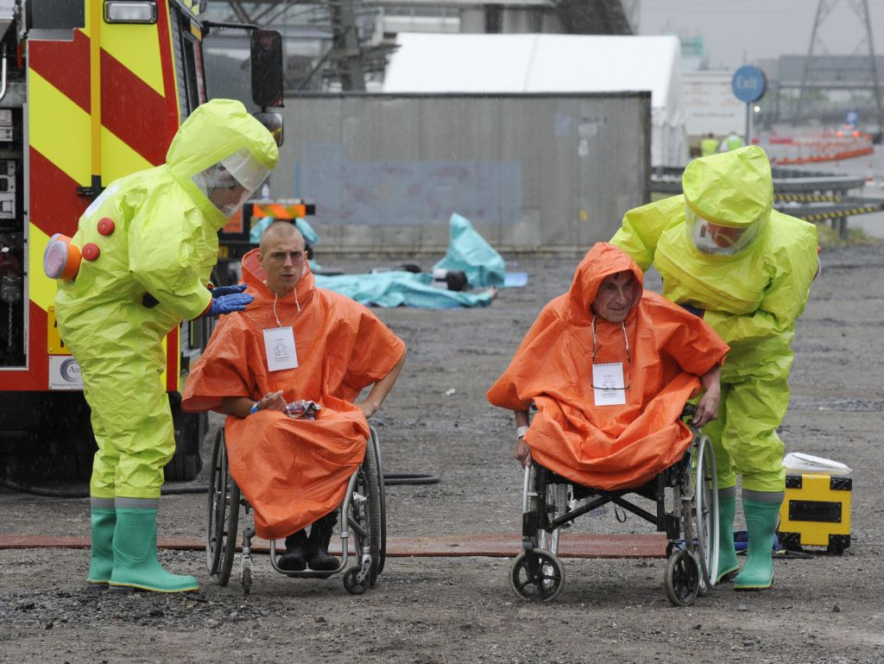
Objectives
- Response of local health services to an incident involving large numbers of disabled groups
- NHS resources and capacity necessary to manage an incident involving disabled groups.
- Medical interventions required at the incident site
- Communications processes to warn and inform the public in the immediate aftermath
Exercise Milo sites
An international disabled sporting event is being held at a Stadium in East London. A large number of disabled athletes from various countries are attending as well as spectators, media and support staff.
A lorry carrying acetic anhydride in drums drives past the stadium and crashes into two minibuses parked outside. Disabled athletes, pedestrians, support staff and the media are injured. Several of the chemical drums burst on impact, releasing their contents.
The casualties have injuries consistent with chemical exposure from acetic anhydride, and blunt or penetrating trauma from the impact. Some casualties manage to leave the scene and self-present at Homerton Hospital.
Incident Site
Aerial view of incident site showing hot zone, warm zone and decon areas
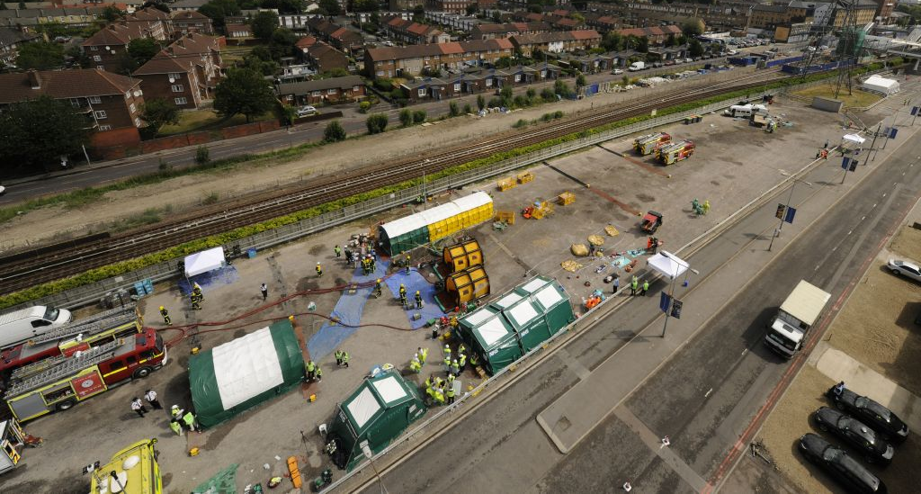
Scale of Exercise
- 5 locations – ExCeL, Homerton Hospital, NHS City and Hackney, London Ambulance Service, NHS London
- Casualties – 96 volunteers (planned for 113)
- Participants – 188 (Incident site), 200 (Homerton)
- Staff – 212 from 19 organisations
- Broadcast media – BBC, PA, print media
- 5am start (for casualty preparation)
- First 45 minutes of play pre-scripted

Casualty volunteers
- Aged 18-60
- Total 96 = 37 disabled and 59 able-bodied
- 113 required but 17 no-shows
- Mental health disabilities excluded – issues of capacity and consent
- Unique ID number – labelled casualty and prostheses, timing chip
Category | Number
Blind or visually impaired | 3
Deaf | 2
Amputee | 29
Wheelchair user | 3
Other disability | 0
Able-bodied | 59
Total | 96

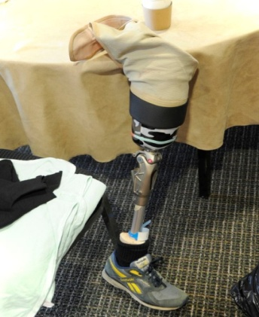
Casualties and scripts
- 70 scripted casualties
- Contain medical history
- Hourly observations
- Unique to volunteer
- Extra details given at hospital
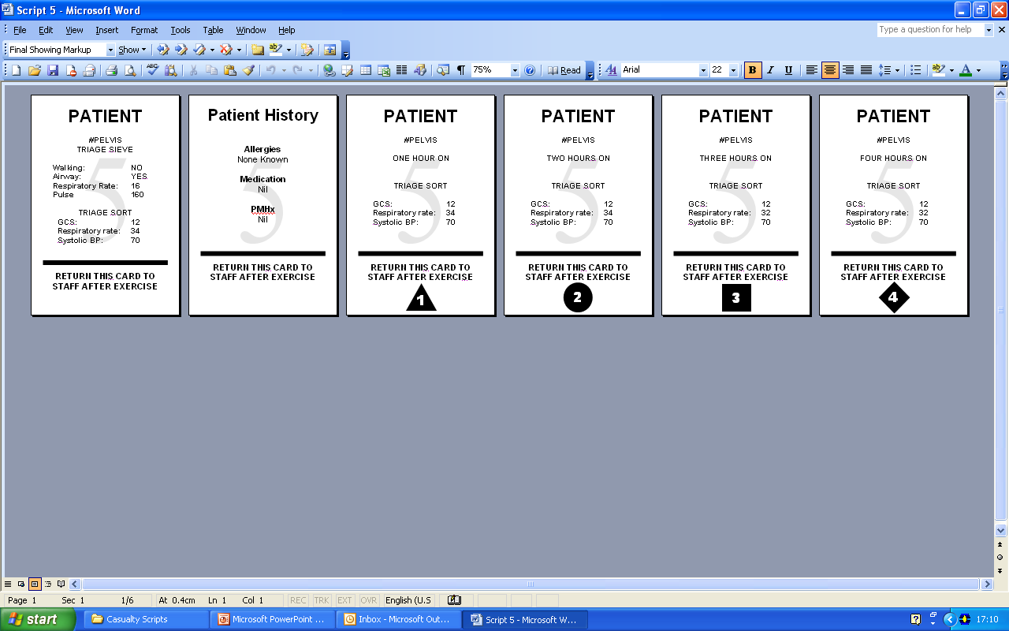
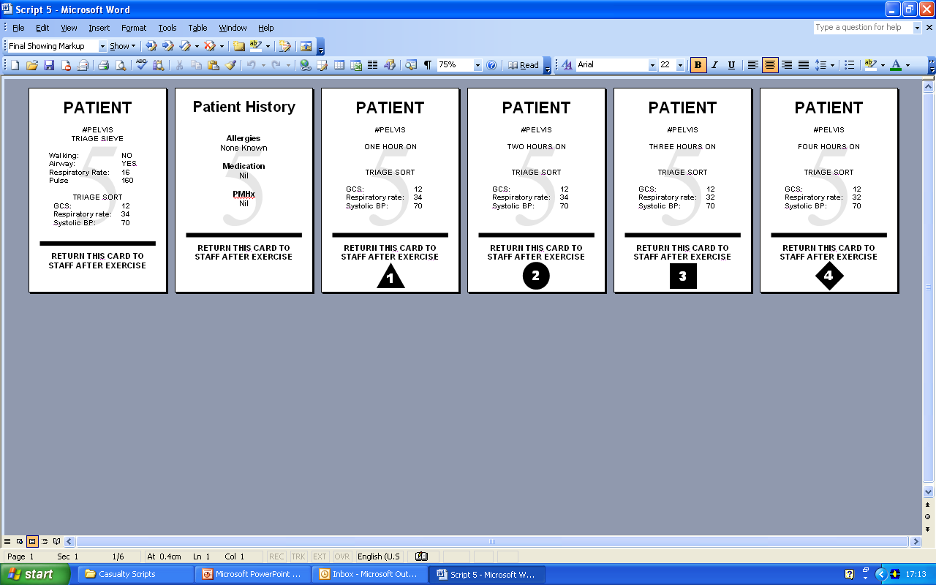

Evaluation
    - Feedback questionnaires, debriefing sessions
    - Discussion groups: feedback directly from casualties
    - Timing and tracking: chips and mats
    - Showering performance: a fluorescent tag and UV-illuminated photography
Comprehensive – need robust evaluation strategy, and involve from beginning of project

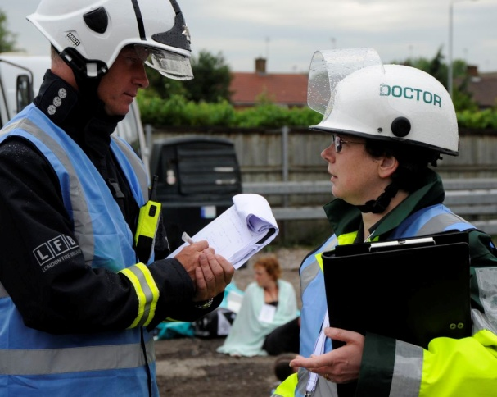

Incident site – key events
- General communication with casualties at all stages of MD1 showering process was poor
- Clinical decontamination times outside planning assumptions
- Leg amputees (P3) not decontaminated by end of exercise
No further clinical assessment of casualties after assembly at MD1
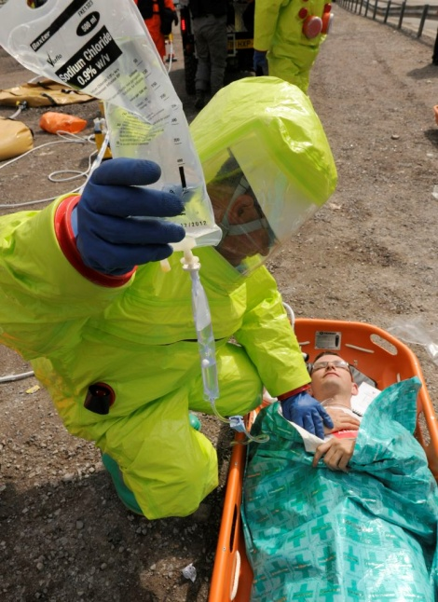
Incident site activity
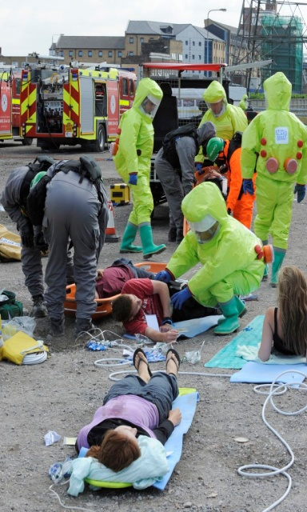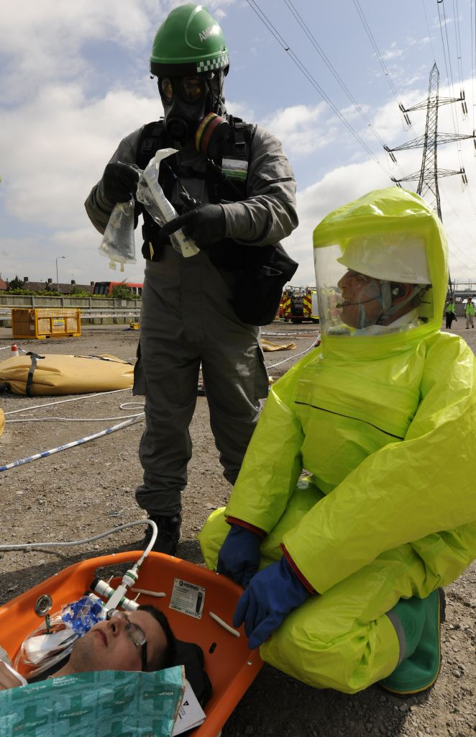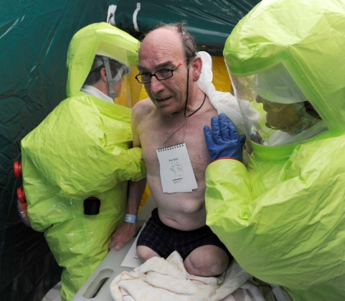
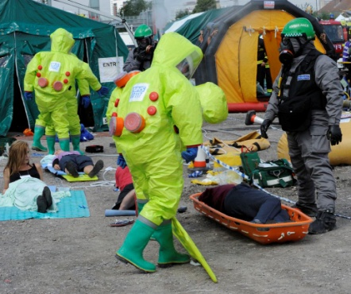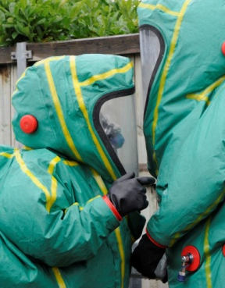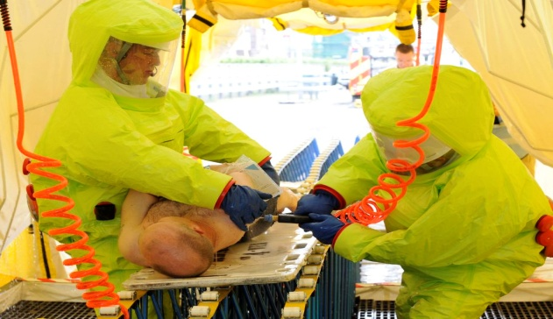

Homerton Hospital – key events
- Self-presenting casualties – decontamination set up
- Lockdown of hospital
- ED remained open to the public during exercise
- Realism and scope - casualty volunteers ended up in theatre on the operating table
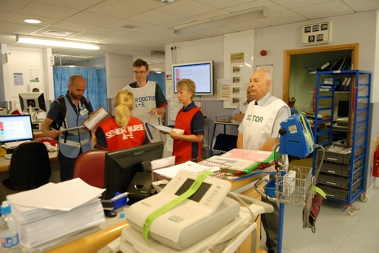
Homerton Hospital activity
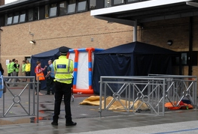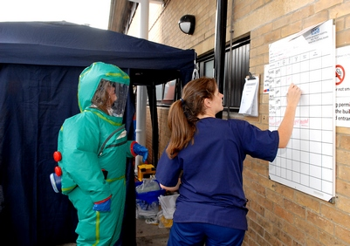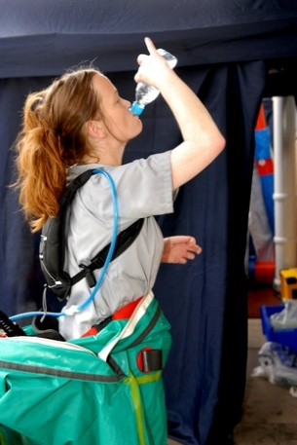
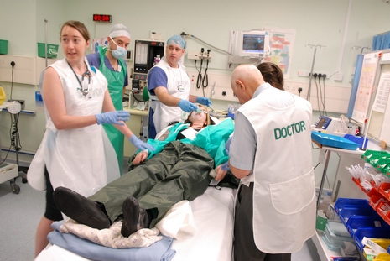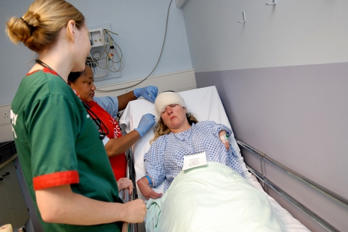
Key recommendations
Decontamination processes
- Role and scope of FRS and ambulance staff in MD1 re casualty assessment, assistance, contact
- Review of showering times and planning assumptions to reflect realistic washing times
- Communication of instructions for showering in MD1 – written, visual, pictorial aids
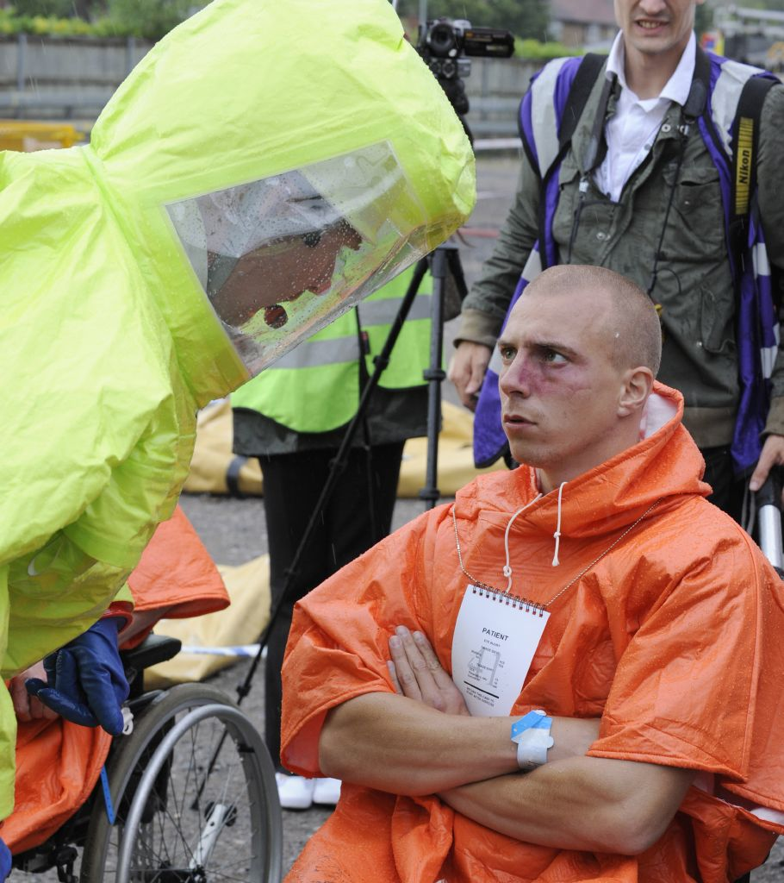

Key recommendations
Hot Zone Working
- Provision of respiratory protection to casualties in hot zone, particularly those unable to self-extricate
- Safety practices for hospital staff coming into contact with potentially contaminated casualties
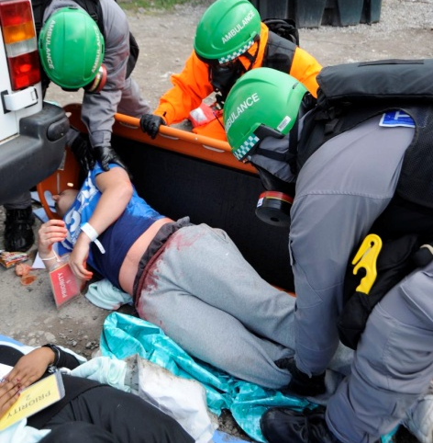
Key recommendations
Casualty Challenges
- Guidance for decontamination of prosthetic limbs and other essential mobility aids
Review triage systems to consider implications for disabled and non-mobile P3 casualties
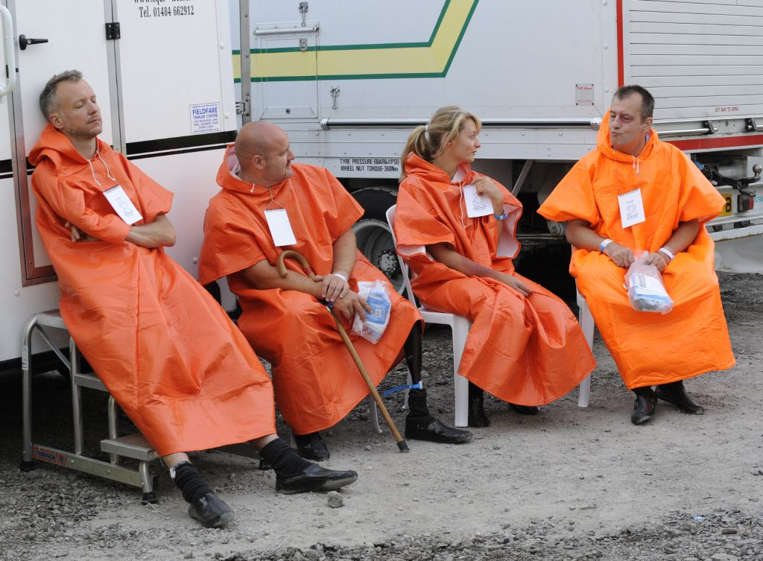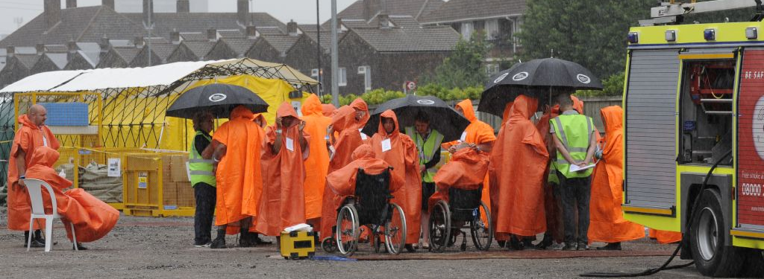
    - Apply to other vulnerable groups – babies, toddlers, elderly
    - Practicalities of exercising disabled – special requirements but don’t be put off by this – makes rest of your planning better, and ultimately your decontamination plans
    - Future trials – volunteers – age, sex, ethnicity, ability

