Background of the EUNAD project (EUTOPA, EUTOPA-IP)

European Network for Psychosocial Crisis Management
Prof. Dr. Robert Bering
Center of Psychotraumatology/ Alexianer
University of Cologne/ Faculty of Human Science

Partners in the Project are:
Germany, Center for Psychotraumatology, Alexianer, Krefeld
Czech Republic, Charles University, Prague
Denmark, University of Southern Denmark
Germany, Federal office of civil protection and disaster assistance, Bonn
Norway, Norwegian Center of Violence and Traumatic Stress Studies, Oslo

Objectives
• Initiatives of the European Commission
for psychosocial aftercare in cases of disaster
• Target Group Intervention Program (TGIP)
• Screening debate
• Examples TGIP/ Cologne Risk Index (CRI)
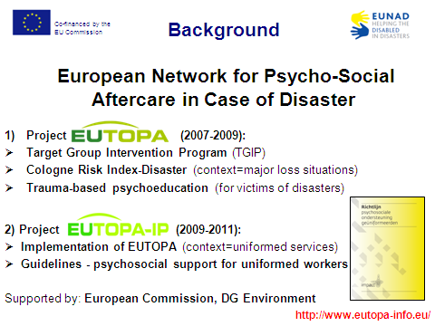
Time Course of Traumatic Stress
How can we improve the psychosocial aftercare for people affected by disasters?
How can we prevent a traumatic process and support recovery?

Objectives of EUTOPA project are:
Implementation of EUTOPA products like
1. Multidisciplinary Guideline on Early Intervention
2. Target Group Intervention Program
Target Group Intervention Program (TGIP)
Manual I: Implementing the Cologne Risk Index-Disaster
Manual II: Measures for TGIP
Manual III: Trauma-based psychoinformation
Manual IV: Rehabilitation of stress response syndroms

• TGIP offers a framework to plan psychosocial interventions from the
acute phase up to the mid- and longterm course.
• TGIP is based on psychosocial and clinical experiences as well as
empirical evidence, TGIP offers a tool of measures, depending on the
riskprofile of the affected.
• TGIP contains the concrete description of actions for a gradual
intervention planing that focusses first of all on the mid- and longterm
traumatic process.
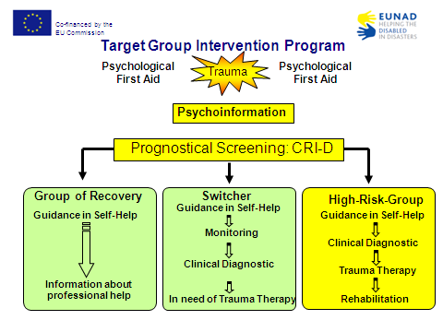

What makes the difference between
Guidelines and TGIP?

TGIP
• Is a crisis intervention program of best practice
• is based on a bio-psycho-social model
• Is concipated on a time course model
• Dynamics between risk and protective factors
• Identifies target groups of risk (Cologne Risk Index)
• Is adapted to different types of trauma incidents
• Emphasizes mid- and longterm interventions
• Integrates the ICF
Development and Modification of TGIP
• Collogne victim aid model (Fischer et al., 1997)
• War Zone (Bering et al., 2003)
• Bank Hold Up (Walter, 2003)
• Train Accident Eschede/Brühl (Hammel, 2005)
• PLOT - Terror Attack (Bering et al., 2005)
• EUTOPA – IP Disaster (Schedlich et al., 2007)
• Medical Care (Bering et al., 2007)
• War Zone - Revalidated (Dunker, 2009)
• School shooting (Weber, in preperation)
The screening debate
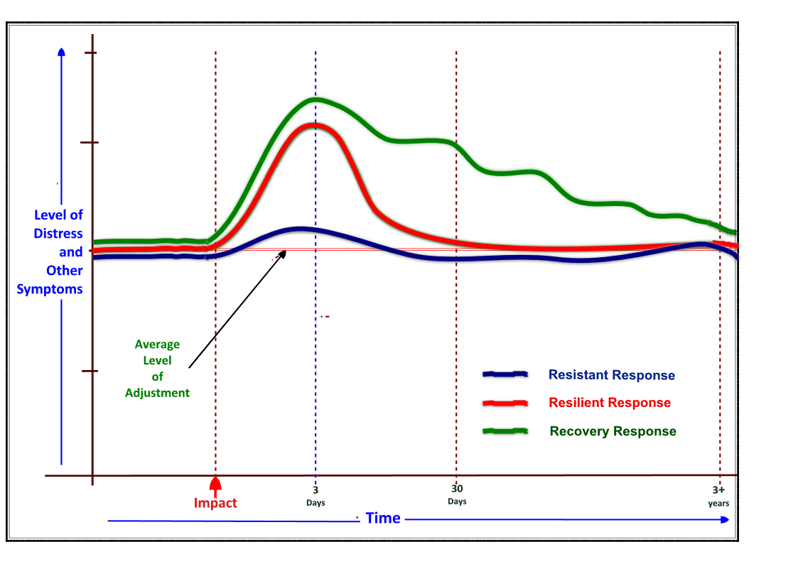
Constructed by Williams R & Kemp V after Layne CM, Warren JS, Watson PJ, Shalev AY.

Guidelines recommend:
• As yet the study group does not recommend the early tracing of those affected who have a high risk of a post-traumatic stress disorder using PTSD questionnaires (IMPACT, p 12)
• At present, it is the conclusion of this guidance that it is not appropriate to screen populations of people for symptoms in the immediate aftermath (days) of a disaster or traumatic event (NATO, p 87).
• No accurate way of screening for the later development of PTSD has been identified (NICE, p 107).
• Formal screening of everyone affected should not occur but helpers should be aware of the importance of identifying individuals with significant difficulties. (TENTS, p 5)
• All Guidelines agree that further studies are necessary.
Prognostical Screening in TGIP
• In TGIP we recommend a prognostical screening of risk factors (CRI), dissociation and PTSD related symptoms.
• Cologne Risk Index-Disaster enables the classification to Group of Recovery, Switchers and High-Risk Group and thereby establishes the basis of TGIP.

Qualitative studies/ Experts opinion
Meta-Analysis
Field Studies
Cologne Risk Index: Questionnaire, half-standardized interview, guidance for taking history

Part A.
Sociodemographic aspects
Part B.
Antecedent factors:
Pretraumatization, stress ...
Post-situational factors:
Social support, appreciation, bodily injury, ability to speak wide open ...
Part C.
Peritraumatic factors:
Uncontrolled and unexpected, life-threatening/ fear of death, peritraumatic dissociation ...
Part D.
Semistandardized assessment of the dynamic in the situation

Intervalidation of the Cologne Risk Index in field studies
A: Lessons learned (acute phase)
• Multidisciplinary and trauma-centered staff is useful
• The everyday needs of populations continue during and after
major incidents (Social workers!)
• Screening of Target Groups at Risk/ Interview can wait
B: Lessons learned (midterm)
• The CRI allows a sufficient prognostical screening and
distinguishes three different groups at risk.
Do not forget:
The CRI is a check list that functions as a precurser for clinical diagnostics.
The Screening and the Diagnostics are two different modules in the TGIP.

Contact:
robert.bering@alexianer-krefeld.de

